RUN TIME: 09:26AM TOWN FUND CHECKS & DIR. DEBITS

|  |  |  |  |  |
| --- | --- | --- | --- | --- |
| D ES C RI PTI ON ACCOUNT NUMBER | | | | AMOUNT |
| PAYROLL AND MISCELLANEOUS EXPENDITURES  BYRON BANK (931) 09/23/24 18383  18383 CERTIFICATE OF DEPOSIT | | | 01-115-00 | $200,000.00  200,000.00 |
| NCPERS (428) 09/26/24 18389  18389 IMRF VOL. INSURANCE | | | 01-215-04 | $32.00  32.00 |
| TOTAL PAYROLL AND MISCELLANEOUS EXPENDITURES  SUPERVISORS DIVISION EXPENDITURES  ABBY PEST ELIMINATION (1167) 09/25/24 13430 BLDG.MAiNT. | | 17190 | 01-10-578-00 | $200,032.00  $45.00  45.00 |
| ALPHA CONTROLS & SERVICES, LLC (21) W48850 BLDG.MAINT. | 09/25/24 | 17191 | 01-10-578-00 | $89.82  89.82 |
| ALPHA CONTROLS & SERVICES, LLC (21)  18384 LIFE SAFETY/INSPECT/FIRE/ELEVATOR PHONE | 09/27/24 | 18384 | 01-10-578-02 | $905.25  905.25 |
| BELVIDERE TOWNSHIP PREMIUM TRUST ACCT. (1309) 18385 HEALTH INSURANCE/DENTAUVISION | 09/26/24 | 18385 | 01-10-560-00 | $13,561.58  13,561.58 |
| BOONE COUNTY COUNCIL ON AGING (112) 18381 SENIOR CITIZEN ACTIVITY | 09/16/24 | 18381 | 01-10-576-00 | $1 1 ,500.oo  1 11500.00 |
| BOONE COUNTY SHOPPER (124)  110157 PRINTING & PUBLISHING | 09/11/24 | 17163 | 01-10-556-00 | $170.63  170.63 |
| BUSINESS CARD (551)  18382 OFFICE SUPPLIES | 09/18/24 | 18382 | 01-10-516-00 | $16.44 |
| CINTAS CORPORATION #355 (1313)  4205201988 JANITOR & SUPPLIES | 09/25/24 | 17192 | 01-10-582-00 | $43.23  43.23 |
| COMCAST (871)  0013108 CAPITAL EQUIP.EXPEND.INC.COMPUTER, | 09/11/24 | 17164 | 01-10-581-00 | $193.73  193.73 |
| COMMONWEALTH EDISON (198)  18379 NEW TWP. BLDG. UTILITIES | 09/04/24 | 18379 | 01-10-573-03 | $986.39  986.39 |
| CULLIGAN OF BELVIDERE (226)  093351 JANITOR & SUPPLIES | 09/25/24 | 17194 | 01-10-582-00 | $7.00  7.00 |
| DEARBORN LIFE INSURANCE CO. (1074)  18388 HEALTH INSURANCE/DENTAUVISION | 09/26/24 | 18388 | 01-10-560-00 | $86.00  86.00 |
| EM BENEFITS (1070)  18386 HEALTH INSURANCE/DENTAUVISION | 09/26/24 | 18386 | 01-10-560-00 | $381.04  381.04 |
| CFC LEASING - WI (1350)  100950934 CAPITAL EQUIP.EXPEND.INC.COMPUTER, | 09/11/24 | 17165 | 01-10-581-00 | $205.00  205.00 |
| CFL ENVIRONMENTAL (1389)  1.1134874 JANITOR & SUPPLIES | 09/11/24 | 17166 | 01-10-582-00 | $29.75  29.75 |
| MORGAN MAINT„INC. (553)  39019 JANITOR & SUPPLIES | 09/11/24 | 17167 | 01-10-582-00 | $682.00  682.00 |
| MORGAN MAINT.,INC. (553)  39003 JANITOR & SUPPLIES | 09/25/24 | 17195 | 01-10-582-00 | $851.00  851.00 |
| NICOR (580)  15957320003 NEW TWP. BLDG. UTILITIES | 09/11/24 | 17168 | 01-10-573-03 | $52.07  52.07 |

RUN TIME: 09:26AM TOWN FUND CHECKS & DIR. DEBITS

|  |  |  |  |  |
| --- | --- | --- | --- | --- |
| D E SC RI PTI ON | | ACCOUNT NUMBER | | AMOUNT |
| SUPERVISOR'S DIVISION EXPENDITURES  PAPER RECOVERY SERVICE CORP. (892) 09/11/24  97176 COMMUNITY TWP.BETTERMENT | | 17169 | 01-10-502-00 | $962.50  962.50 |
| ROCKFORD INFORMATION TECHNOLOGIES, INC. (666) 39476 CAPITAL EQUIP.EXPEND.INC.COMPUTER, | 09/25/24 | 17196 | 01-10-581-00 | $1 ,097.00  11097.00 |
| SALVATION ARMY (702)  18380 SOCIAL SERVICES | 09/11/24 | 18380 | 01-10-502-01 | $7,000.00  7 ,ooo.oo |
| TK ELEVATOR CORPORATION (926) 09/11/24  3008072910 LIFE SAFETY/INSPECT/FIRE/ELEVATOR PHONE | | 17171 | 01-10-578-02 | $904.84  904.84 |
| VISION SERVICE PLAN (1068) 09/26/24  18387 HEALTH INSURANCE/DENTAUVISION | | 18387 | 01-10-560-00 | $147.60  147.60 |
| TOTAL SUPERVISORS DIVISION EXPENDITURES  ASSESSORS DIVISION EXPENDITURES  BELVIDERE TOWNSHIP PREMIUM TRUST ACCT. (1309) 09/27/24  18385 HEALTH INSURANCE | | 18385 | 01-20-534-00 | $39,917.87  $4,785.98  4,785.98 |
| BUSINESS CARD (551)  18382 | 09/18/24 | 18382 | 01-20-545-02 | $28.25  28.25 |
| CINTAS CORPORATION #355 (1313) 09/25/24  4205201988 JANITORIAL -ASSESSOR/RT. 76 | | 17192 | 01-20-550-00 | $43.23  43.23 |

# COMCAST (871) 09/11/24 17164 $63.30

 01-20-545-02 63.30

|  |  |  |  |  |
| --- | --- | --- | --- | --- |
| COMCAST (871)  877110374103129 TELEPHONE | 09/25/24 | 17193 | 01-20-536-00 | $271.45 |
| CULLIGAN OF BELVIDERE (226)  093351 JANITORIAL-ASSESSOR/RT. 76 | 09/25/24 | 17194 | 01-20-550-00 | $7.00  7.00 |
| DEARBORN LIFE INSURANCE CO. (1074)  18388 HEALTH INSURANCE | 09/26/24 | 18388 | 01-20-534-00 | $43.00  43.00 |
| EM BENEFITS (1070)  18386 HEALTH INSURANCE | 09/26/24 | 18386 | 01-20-534-00 | $97.64  97.64 |
| CFL ENVIRONMENTAL (1389)  SEPTEMBER JANITORIAL - ASSESSOR/RT. 76 | 09/11/24 | 17166 | 01-20-550-00 | $29.75  29.75 |
| ST. ANGEL, MICHAEL (1118)  SCHOOL TRAINING, SCHOOLS | 09/25/24 | 17197 | 01-20-538-00 | $364.50  364.50 |
| STRATUS NETWORKS (1420)  213299 FIBER OPTICSfTECHNOLOGY | 09/11/24 | 17170 | 01-20-545-03 | $1,069.22  I ,069.22 |
| VISION SERVICE PLAN (1068) 18387 HEALTH INSURANCE | 09/26/24 | 18387 | 01-20-534-00 | $48.78  48.78 |

# TOTAL ASSESSORS DIVISION EXPENDITURES $6,852.10

|  |  |  |
| --- | --- | --- |
| RUN TIME: 09:26AM | TOWN FUND | CHECKS & DIR. DEBITS |
| D ESC RI PT I O N |  | ACCOUNT NUMBER AMOUNT |

## TOWN FUND RECAP

 CODE DESCRIPTION AMOUNT

|  |  |
| --- | --- |
| PAYROLL AND MISCELLANEOUS | 200,032.00 |
| 10 SUPERVISOR'S DIVISION | 39,917.87 |
| 20 ASSESSOR'S DIVISION | 6,852.10 |
| TOTAL TOWN FUND EXPENDITURES | 246,801.97 |

ROAD & BRIDGE FUND

## PAYROLL AND MISCELLANEOUS EXPENDITURES

|  |  |  |  |  |
| --- | --- | --- | --- | --- |
| BYRON BANK (931) 09/23/24 11926  11926 CERTIFICATE OF DEPOSIT | | | 02-115-00 | $175,000.00  175,000.00 |
| BYRON BANK (931) 09/24/24 11927  11927 CERTIFICATE OF DEPOSIT | | | 02-115-00 | $150,000.00  150,000.00 |
| TOTAL PAYROLL AND MISCELLANEOUS EXPENDITURES  ROAD & BRIDGE DIVISION EXPENDITURES  AIRGAS USA, LLC (18) 09/25/24  5510291538 SUPPLIES/GAS & OIUEPA ANN.FEES | | 5706 | 02-30-644-00 | $325,000.00  $59.36  59.36 |
| BELVIDERE TOWNSHIP PREMIUM TRUST ACCT. (1309)  11929 HEALTH & HOSP. PREMIUM | 09/26/24 | 11929 | 02-30-620-00 | $3,135.06  3,135.06 |
| CINTAS CORPORATION #355 (1313) 14916741 UNIFORMS | 09/11/24 | 5698 | 02-30-656-03 | $260.32  260.32 |
| CINTAS CORPORATION #355 (1313)  4205201988 DUMPSTER/JANITOR/MISC./BANK CHGS. | 09/25/24 | 5707 | 02-30-656-02 | $43.23  43.23 |
| COMCAST (871)  WIN TELEPHONE/CALLER ID | 09/11/24 | 5699 | 02-30-600-02 | $63.30  63.30 |
| COMMONWEALTH EDISON (198)  2406239000 SUPPLIES-MUNC.ST LIGHTSITORNADO SIRENS | 09/11/24 | 5700 | 02-30-644-01 | $134.25  134.25 |
| COMMONWEALTH EDISON (198)  11924 SUPPLIES-MUNC.ST LIGHTS/TORNADO SIRENS | 09/11/24 | 11924 | 02-30-644-01 | $223.20  223.20 |
| COMMONWEALTH EDISON (198)  11925 SUPPLIES-MUNC.ST LIGHTSffORNADO SIRENS | 09/11/24 | 11925 | 02-30-644-01 | $125.83  125.83 |
| CONSERV FS (978)  33039393 TOTAL MAINT. OF ROADS (INCLUDES | 09/25/24 | 5708 | 02-30-645-00 | $96.10  96.10 |
| DEARBORN LIFE INSURANCE CO. (1074) 11932 HEALTH & HOSP. PREMIUM | 09/26/24 | 11932 | 02-30-620-00 | $21.50  21.50 |
| EM BENEFITS (1070)  11930 HEALTH & HOSP. PREMIUM | 09/26/24 | 11930 | 02-30-620-00 | $66.01  66.01 |
| FRONTIER (1 1 17)  5442029 TELEPHONE/CALLER ID | 09/11/24 | 5701 | 02-30-600-02 | $96.94  96.94 |
| CFL ENVIRONMENTAL (1389)  U134874 DUMPSTER/JANITOR/MISC./BANK CHGS. | 09/11/24 | 5702 | 02-30-656-02 | $56.26  56.26 |
| HI-VIZ, INC. (1020)  12582 SUPPLIES [CULVERTS/SIGNS | 09/25/24 | 5709 | 02-30-643-00 | $900.00  900.00 |

|  |  |  |  |  |  |
| --- | --- | --- | --- | --- | --- |
| RUN DATE: 10/11/24  RUN TIME: 09:26AM | BILLS PAID REPORT FOR SEPTEMBER, 2024  ROAD & BRIDGE FUND | | PAGE: 4  CHECKS & DIR. DEBITS | | |
| D ESC RI PTI ON |  | | ACCOUNT NUMBER | | AMOUNT |
| ME-NARDS-CHERRY VALLEY (534)  65927 TOTAL MAINT. OF ROADS (INCLUDES | ROAD & BRIDGE DIVISION EXPENDITURES  09/25/24 | | 5710 | 02-30-645-00 | $257.88  257.88 |
| NAPA AUTO PARTS (111)  11720 REPAIRS TO MACHINERY | 09/11/24 | | 5703 | 02-30-654-00 | $194.27  194.27 |
| NICOR (580)  08363020002 SUPPLIES-MUNC.ST LIGHTSfTORNADO SIRENS | | 09/11/24 | 5704 | 02-30-644-01 | $55.44  55.44 |
| VISION SERVICE PLAN (1068)  11931 HEALTH & HOSP. PREMIUM | | 09/26/24 | 11931 | 02-30-620-00 | $30.02  30.02 |
| WOLTER, INC (1402)  622402173 REPAIRS TO MACHINERY | | 09/11/24 | 5705 | 02-30-654-00 | $1 , 104.72  1,104.72 |

# TOTAL ROAD & BRIDGE DIVISION EXPENDITURES $6,923.69

## ROAD & BRIDGE FUND RECAP CODE DESCRIPTION AMOUNT

|  |  |
| --- | --- |
| PAYROLL AND MISCELLANEOUS | 325,000.00 |
| 30 ROAD & BRIDGE DIVISION | 6,923.69 |
| TOTAL ROAD & BRIDGE FUND EXPENDITURES | 331,923.69 |

GENERAL ASSISTANCE FUND

## PAYROLL AND MISCELLANEOUS EXPENDITURES

|  |  |  |  |
| --- | --- | --- | --- |
| BYRON BANK (931)  12524 CERTIFICATE OF DEPOSIT | 10/09/24 12524 | 03-115-00 | $150,000.00  150,000.00 |
| SOLUTIONS BANK (626)  12525 CERTIFICATE OF DEPOSIT | 09/30/24 12525 | 03-115-00 | $50,000.00  50,000.00 |

# TOTAL PAYROLL AND MISCELLANEOUS EXPENDITURES $200,000.00

## GENERAL ASSISTANCE FUND RECAP

## CODE DESCRIPTION AMOUNT

|  |  |
| --- | --- |
| PAYROLL AND MISCELLANEOUS | 200,000.00 |
| TOTAL GENERAL ASSISTANCE FUND EXPENDITURES | 200,000.00 |

BELVIDERE CEMETERY FUND

BELVIDERE CEMETERY ASSOC. (66) 09/12/24 2011 $92,950.00

## 2ND PAY BELVIDERE CEMETERY MAINTENANCE 04-00-810-00 92,950.00



TOTAL BELVIDERE CEMETERY FUND EXPENDITURES $93,061.63

# TOTAL PAYROLL AND MISCELLANEOUS EXPENDITURES $150,000.00

## ROAD & BRIDGE-MACHINERY & HOUSING FUND RECAP CODE DESCRIPTION AMOUNT PAYROLL AND MISCELLANEOUS 150,000.00 TOTAL ROAD & BRIDGE-MACHINERY & HOUSING FUND EXPENDI 150,000.00

SOCIAL SECURITY FUND

|  |  |  |
| --- | --- | --- |
| RUN DATE: 10/11/24  RUN TIME: 09:26AM | BILLS PAID REPORT FOR SEPTEMBER, 2024  ROAD & BRIDGE-MACHINERY & HOUSING FUND | PAGE: 5  CHECKS & DIR. DEBITS |
| ESC RI PT I O N |  | ACCOUNT NUMBER AMOUNT |
| BYRON BANK (931)  CERTIFICATE OF DEPOSIT | PAYROLL AND MISCELLANEQUS EXPENDITURES  09/30/24 | $150,000.00  09-115-00 150,000.00 |

## PAYROLL AND MISCELLANEOUS EXPENDITURES

## STILLMAN BANK (1275) 09/30/24 1384 $50,000.00

1384 CERTIFICATE OF DEPOSIT 10-115-00 50,000.00

# TOTAL PAYROLL AND MISCELLANEOUS EXPENDITURES $50,000.00

## SOCIAL SECURITY FUND RECAP

### CODE DESCRIPTION AMOUNT



PAYROLL AND MISCELLANEOUS 50,000.00

TOTAL SOCIAL SECURITY FUND EXPENDITURES 50,000.00

|  |  |  |  |  |  |
| --- | --- | --- | --- | --- | --- |
| RUN DATE: 1011 1/24  RUN TIME: 09:26AM |  |  | BILLS PAID REPORT FOR SEPTEMBER, 2024  SUMMARY ALL FUNDS |  | PAGE: 6 |
|  | BANK ACCOUNT | BANK | DESCRIPTION | AMOUNT |  |
|  | 01-105-00  02-105-00  03-105-00  04-105-00  09-105-00  10-105-00 | 01  02  03 04 09  10 | TOWN-CASH IN BANK  ROAD & BRIDGE-CASH IN BANK  GENERAL ASSISTANCE-CASH IN BANK  BELVIDERE CEMETERY-CASH IN BANK  ROAD & BRIDGE-MACHINERY & HOUSING-CASH IN BANK  SOCIAL SECURITY-CASH IN BANK | 246,801.97  3311923.69  200,000.00  93,061.63  150,000.00  50,000.00 |  |
|  |  |  | TOTAL ALL FUNDS | 1 ,0711787.29 |  |

Each voucher submitted has been audited and approved for payment .

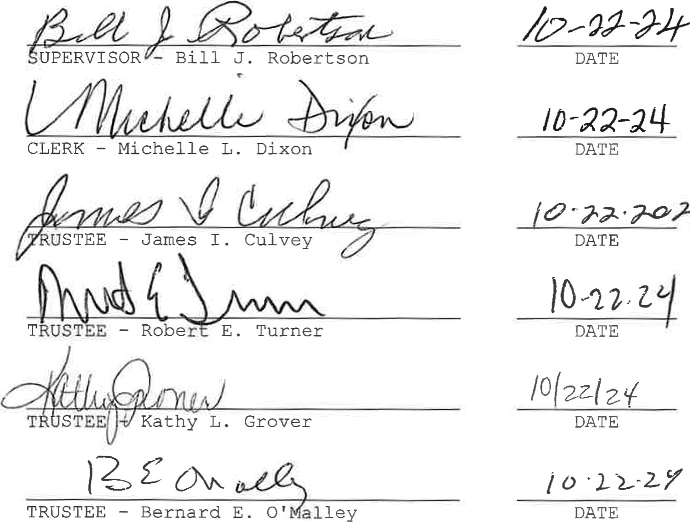

2-46